 **SUID, GUID and Sticky bit**

**SUID ( Set User ID)** :- When we set the SUID bit on any script then that script process will run as a UID of owner of that script, irrespective who is executing it.

# chmod u+s {path of file} or

# chmod 4755 {path of file}

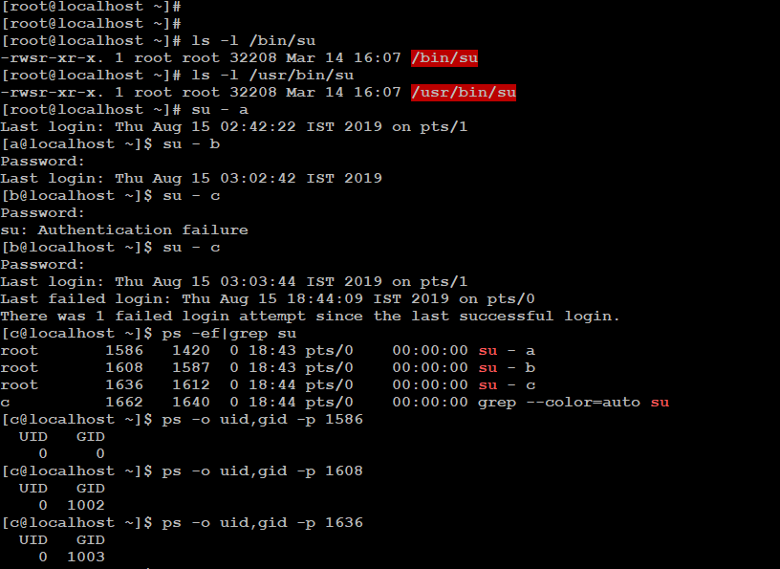

**SGID (Set Group ID)** :-

SGID bit on the directory:- If SGID is set on the directory then all subdirectories and files created inside will get the same group ownership as the main directory.

# groupadd sabre

# usermod -G sabre (user name1)

# usermod -G sabre (user name2)

# mkdir /testdir

# chgrp sabre /testdir

# chmod 775 /testdir

Now set SGID

# chmod g+s /testdir or

# chmod 2775 /testdir

Now you will create a directory or file inside /testdir directory it will take sabre group ownership

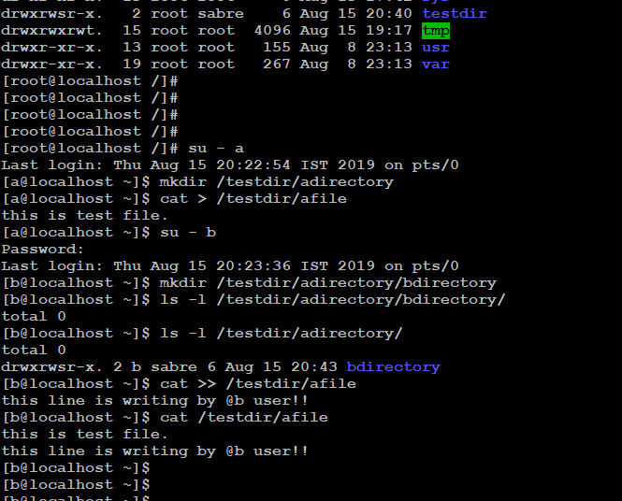

**SGID bit on file**:- when any user executes a file with SGID bit, it will be executed with the group ownership of that file instead of who is running it.

# chmod g+s {file path}

**Sticky bit** :- When we share any directory to all then we use sticky bit on that directory so that no one could change the another user directory rather than root and owner of that directory. For eg:-

# chmod +t /stickybit(path of the file) or

# chmod 1777 /stickybit(path of the file)

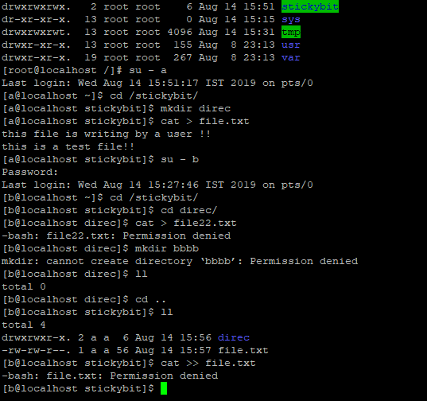

Thanks and Regards,

**Nitin Singh Sen**